1. **What do you mean by Entity-Relationship Diagram? Explain.**

**Ans:** An entity-relationship diagram (ERD) is a graphical representation of an information system that shows the relationship between people, objects, places, concepts or events within that system. An ERD is a [data modeling](http://searchdatamanagement.techtarget.com/definition/data-modeling) technique that can help define business processes and can be used as the foundation for a [relational database](http://searchsqlserver.techtarget.com/definition/relational-database) [1].

Three main components of an ERD are the [entities](http://whatis.techtarget.com/definition/entity), which are objects or concepts that can have data stored about them, the relationship between those entities, and the [cardinality](http://whatis.techtarget.com/definition/cardinality), which defines that relationship in terms of numbers [1].

For example, an ER diagram representing the information system for a company's sales department might start with graphical representations of entities such as the sales representative, the customer, the customer's address, the customer's order, the product and the warehouse. (See diagram) Then lines or other symbols can be used to represent the relationship between entities, and text can be used to label the relationships [1].

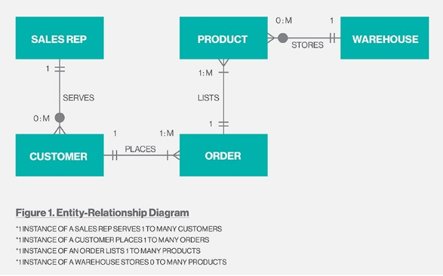

Fig: Entity Relationship Diagram [1].

1. **Define entity and give an example.**

**Ans:** Entity is a real world object which has its unique identification. It is enclosed in rectangle and has its own property. The property of entity is known as attribute.

Eg: Student is an entity having attributes Name, College, Student_id, Phone_no, Address.

Entity set is the collection of entities having similar attribute of same type.

Eg: set of all customers.

1. **Explain the difference between an entity class and an entity instance.**

**Ans:** An entity is something that can be identified in the users' work environment, something that the users want to track. Entities of a given type are grouped into entity classes. An entity instance is the representation of a particular entity. Entity instances have identifiers. Identifiers are attributes that name, or identify, entity instances [2].

1. **Define attributes and its types.**

**Ans:** Attributes are properties that describe the entity's characteristics [2].

Types of attributes:

* Simple and Composite attributes:

Simple attributes are those attributes which are not further divisible.

E.g.: Student id.

Composite attributes are those attributes which can be further sub divided.

E.g.: Student name can be divided as First name and Last name.

* Single Valued and Multivalued attributes:

The single-value attribute can only have one value, while the multi-valued attributes usually can store multiple data in them [3].

E.g.: Student phone number can be considered as multivalued attribute while student last name can be considered as single valued attribute.

* Store and derived attributes:

An attribute that supplies a value to the related attribute is stored attribute [4].

E.g.: Date of birth

An attribute that’s value is derived from a stored attribute is known as derived attribute.

E.g.: age, and its value is derived from the stored attribute date of birth [4].

1. **What is derived attributes?**

**Ans:** An attribute that’s value is derived from a stored attribute is known as derived attribute.

E.g.: age, and its value is derived from the stored attribute date of birth [4].

1. **Define relationship and give an example.**

**Ans:** A relationship is an association among two or more entities. A relationship set is a set of relationships of same type.

E**.**g.: For two entity sets: Customer and Account, we can define relationship set Depositor which associates each Customer to their corresponding account he/she has.

**References:**

1. What is entity relationship diagram? - Definition from WhatIs.com- SearchCRM

Url: <http://searchcrm.techtarget.com/definition/entity-relationship-diagram> [27/08/2015]

1. DBMS - Interview Questions and Answers Page 4- Indiabix.com

Url: <http://www.indiabix.com/technical/dbms/4> [27/08/2015]

1. E/R Model: Type of Attributes- Database Management

Url: <http://databasemanagement.wikia.com/wiki/E/R_Model:_Type_of_Attributes> [27/08/2015]

1. Attribute Types- [www.jkinfoline.com](http://www.jkinfoline.com)

Url: <http://www.jkinfoline.com/attribute-types.html> [27/08/2015]

1. Dgjd